

WESTERN UNIVERSITY OF HEALTH SCIENCES
Accounts Payable Direct Deposit Authorization

Please complete this form with your bank name, routing number and account number for all direct deposit payments paid through Western University Accounts Payable Department

TO: UNIVERSITY FINANCIAL SERVICES & TREASURY (ACCOUNTS PAYABLE):
I authorize you and the financial institution listed below to initiate electronic credit entries, and if necessary, debit entries and adjustments for any credit entries in error to the account listed below.

Initial Authorization Change Authorization

Account No Financial Institution

Checking Savings Routing/ABA No

Add Change Delete Adds & Changes: Net or Amount
___________________________________________________________________________________________________________

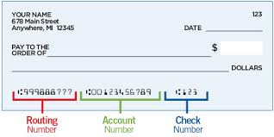

___________________________________________ ______________________
Signature Date

Print Name

