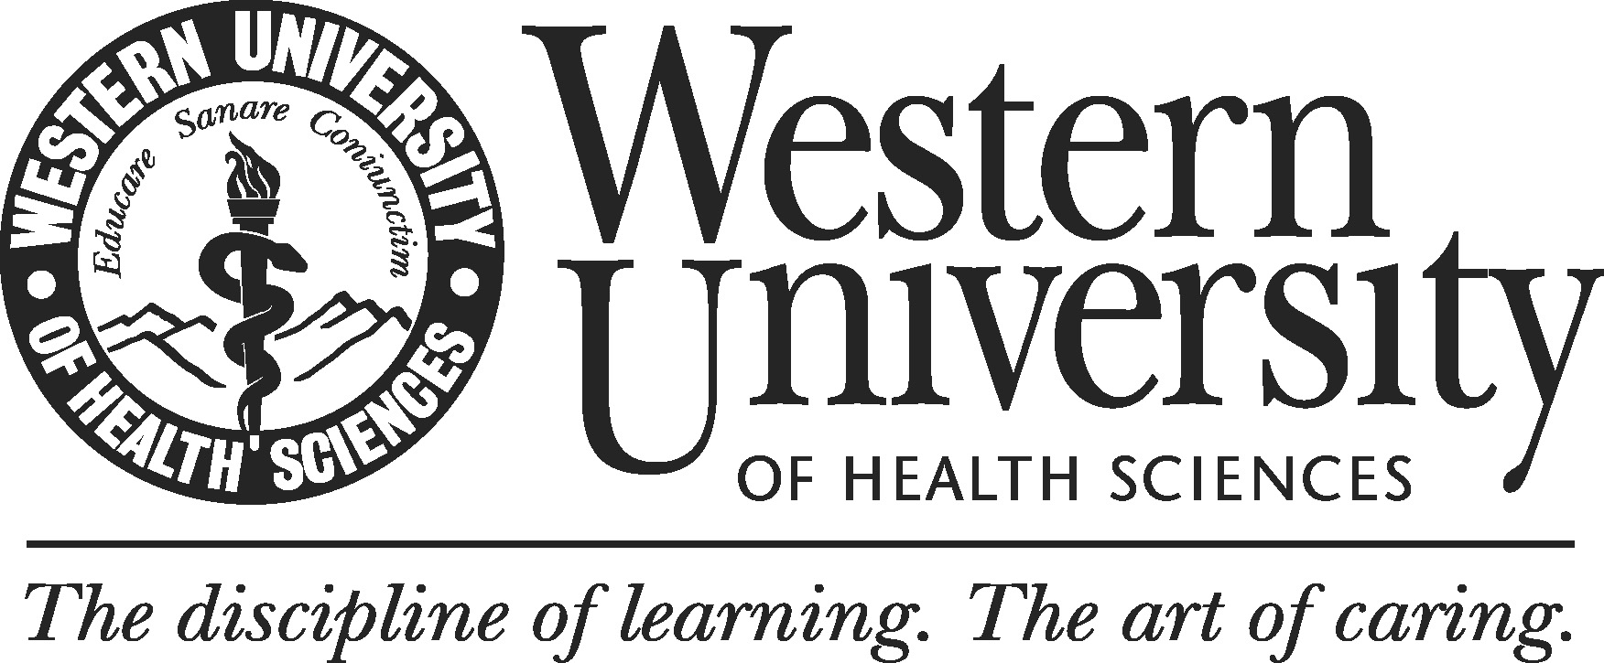

Co-curricular Program
Suggested Data Exhibits Checklist

A self-study should contain analyses of data regarding the program’s quality and viability/sustainability. The table below is a list of the data elements to expound upon in your self-study report. It also provides the information where you can find the data.

 | Data Exhibits | Where to Find
Standard 1. Mission and Vision
 | 1. Date of program’s establishment | IRE
 | 2. Program’s mission | Program’s website
 | 3. Program’s goals | Program’s website
Standard 2. Products and Services
 | 1. Program utilization statistics by students | Program
 | 2. Program utilization statistics by employee | Program
Standard 3. Program Fitness
 | 1. Number of the staff | IRE, and/or BOT November report
 | 2. Staff’s demographics (age, gender and ethnicity) | IRE, and/or BOT November report
 | 3. Distribution of staff’s years at WesternU | Staff Qualifications Table
 | 4. Staff’s skill | Staff Qualifications Table
 | 5. Student-staff ratio for the past 5 years | Staff Qualifications Table
 | 6. Employee-staff ratio for the past 5 years | BOT November
 | 7. Physical space (office, meeting and other relevant spaces) | Facilities
 | 8. Computers | IT
 | 9. Staff support services (IT, etc.) | IT
 | 10. Staff participation in development opportunities related to the program | LEAD
 | 11. Operational budget (revenues and expenditures) and trends over a past 3-5 years period | BOT November report
Standard 4. Program Effectiveness
 | 1. Program learning outcomes | Program website
 | 2. Annual assessment report | IRE Assessment SharePoint

