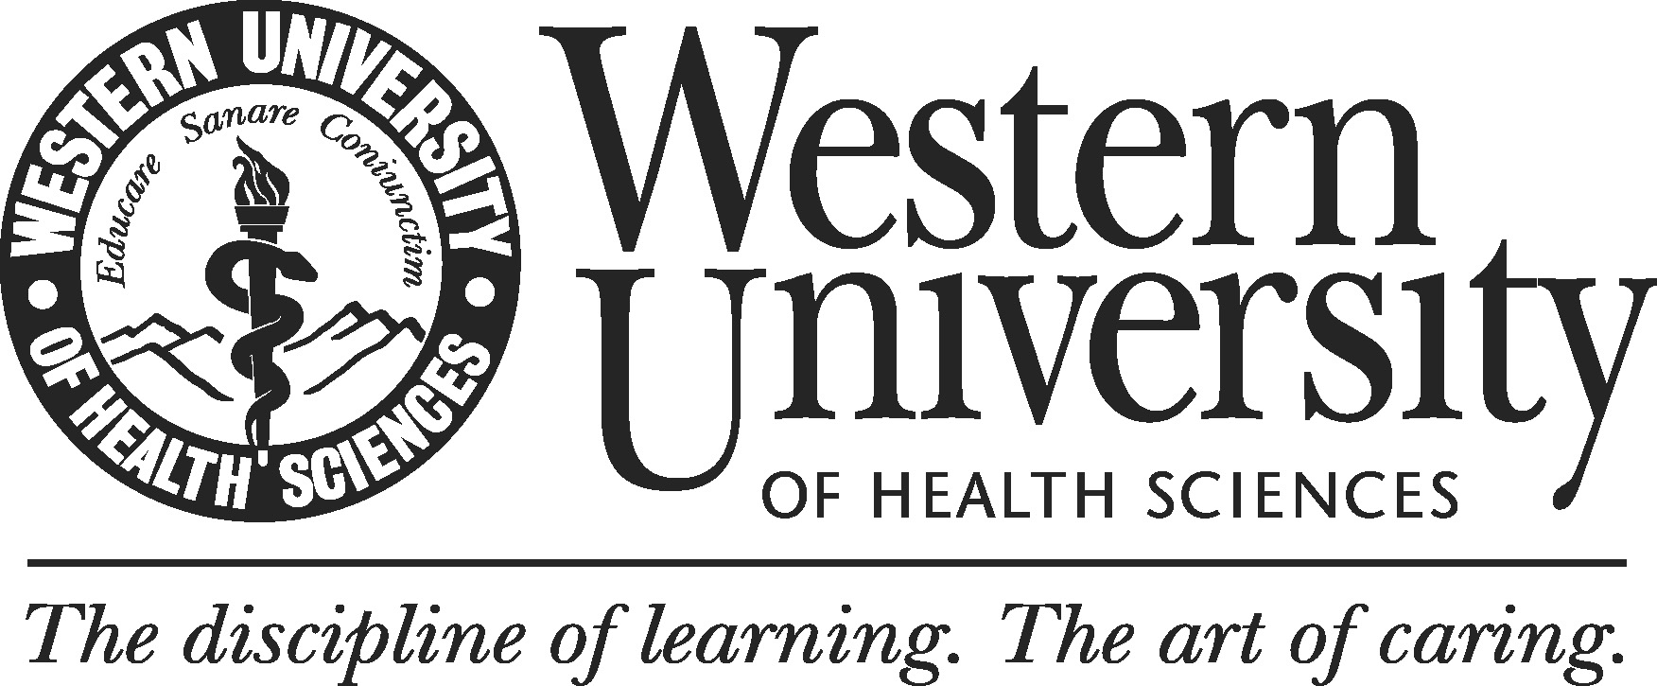

Western University of Health Sciences
Academic Program Review Self-study Report Template

Self-study Report of
[PROGRAM]
Western University of Health Sciences

Submitted
[DATE]

Prepared by
[Name of the Self-study Chair]
[Name of the Dean]
[Names of the Self-study Team Members (if applicable)]

Table of Contents

1. Executive Summary

2. Report Body
1) Introduction
2) Response to Standards
Standard 1. Mission, History and goals of the Program
Standard 2. Student Learning Outcomes
Standard 3. Assess the Curriculum
Standard 4. Assess the Faculty
Standard 5. Assess the Student Body
Standard 6. Assess the Physical Facilities
Standard 7. Assess the Staff
Standard 8. Assess the External Environment of the Program

3. Concluding Statement

1. Executive Summary
Instructions:
The executive summary should:
- include a brief background statement (100 words or so) to help place self-study into context.
- list program’s major strengths.
- list areas for improvement.
- list proposed actions to improve on a weakness or capitalize on strength.

2. Report Body
1) Introduction
Instructions:
Provide context that you feel is important for interpreting the report; overview approach used to complete the self-study.

2) Response to Standards
The body of the report should address each program review standard, section by section. There are eight major standards that require a thoughtful, data-driven response.

Standard 1. Mission, History and Goals of the Program

Prompts:
- Is the program’s mission appropriate to the field?
- Are there plans in place to achieve and assess mission fulfillment?

Related Documentation:
Program’s Catalog

1.1 – The program’s purpose is consistent with the mission and vision of the University and appropriate to their field.
Instructions:
Discuss the purpose of the program. Provide a brief history of the program (date of establishment, number of graduates to date, significant milestones achieved, etc.). Include a statement of the connection of the degree program mission to Western University's Mission statement and its consistency with expectations in the field.

1.2 – The program defines mission fulfillment and plans are in place to achieve and measure related outcomes.
Instructions:
Describe mission fulfillment. Provide plans in place to achieve and assess mission fulfillment.
Standard 2. Student Learning Outcomes
Prompts:
- Does the program provide evidence that demonstrate achievement of student learning outcomes?
- Are outcome metrics evaluated to assess program effectiveness and to inform program improvement efforts?

Related Documentation:
Program’s Catalog, Curriculum Matrix (Curriculum Map), Sample Syllabi, Annual Assessment Reports, BOT Report (March)

2.1 – The program has a set of program learning outcomes that align with the University’s eight institutional outcomes domains. There is evidence, both direct and indirect, that demonstrates achievement of learning within WesternU’s institutional learning outcome domains.

Instructions:
Specify the program's major student learning outcomes (i.e., what are the students expected to learn or be able to demonstrate upon their successful completion of the program). List sources of evidence, both quantitative and qualitative, and direct and indirect. If applicable, evidence (e.g., faculty review of theses or special projects required by the program using a common assessment rubric for the last few years' graduates, employment rates, employer evaluations, etc.) can be provided as an appendix to the report.

2.2. – Student learning outcomes are regularly reviewed to evaluate the degree to which program learning goals are being met. Assessment results are systematically shared within the program and used to guide curricular decisions.

Instructions:
As part of the review process, the unit should select two outcomes to examine in a rigorous fashion, develop an appropriate assessment measure for each outcome, conduct that assessment, and evaluate the result in terms of any modifications to the curriculum they suggest. While indirect measures may be used to assess each outcome, for each outcome at least one direct measure of student achievement must be used (i.e., direct measures are those which are derived from actual student performance of the expected outcome in contrast to surveys that ask student opinions or employer satisfaction with the graduate). Describe how the program/unit uses student outcomes information in program planning.

Standard 3. Assess the Curriculum

Prompt
- Is the curriculum content well organized, appropriate, and includes generally accepted experiences for the degree? Does the curriculum align stated learning outcomes?

Related Documentation:
Curriculum Matrix (Curriculum Map), Program’s catalog, Sample Syllabi

3.1 – Curriculum content is well organized, appropriate, and includes generally accepted experiences for the degree.
Instructions:
Discuss how the curriculum has been defined to meet the goals of the program and the University. This may include a description of the organization of the curriculum, the core courses, prerequisites, teaching methodologies, "capstone" projects, and other key features.

3.2 – The curriculum provides content that is designed to help students achieve the stated outcomes (all stated outcomes) at the program and institutional levels.
Instructions:
Provide a matrix that identifies what courses provide content and exercises that are designed. Identify any "gaps" (i.e., outcomes for which there is no or insufficient coursework to provide students with the knowledge and skills to meet that outcome). Any actual evidence to support the conclusion that the curriculum satisfactorily meets the goals of the program should be provided in the body of the self-study or an appendix.

3.3 – The program publishes student learning outcomes, at the course, program, and institutional level on all course syllabi.
Instructions:
Identify the extent to which program outcomes are explicitly cited in each course syllabus.

Standard 4. Assess the Faculty
Prompt:
- Is the program adequately staffed and qualified to fulfill the mission and purpose?

Related Documentation:
BOT Report (November, May)

4.1 – The program employs an adequate number of qualified faculty to achieve its educational objectives.
Instructions:
Consider the faculty resources as a whole in light of program goals, assess the adequacy of current faculty in terms of number, distribution by academic rank, specializations, qualifications, full-time versus part-time, faculty demographics.

4.2 – Faculty responsibilities, workload, and training opportunities align with the University’s expectations for teaching, service, scholarship, and research.
Instructions:
Assess faculty research/scholarly activity levels. Describe faculty development activities (i.e., how faculty keep current in their field, programs designed to improve faculty performance). Provide information on the size, type and source of any external grants obtained by the faculty. Assess the adequacy of faculty support services (software, library holdings, etc.) to meet faculty needs.

Standard 5. Assess the Student Body
Prompts:
- Does the program periodically review admission data?
- Is the data used to inform recruitment and curricular modifications?
- Do student academic support services ensure quality and facilitate the attainment of the programmed University educational objectives?

Related Documentation:
BOT Report (August, November, March), Program Catalog, Academic Outcomes

5.1 – The program periodically reviews admissions data, disaggregated by demographic categories, including data on applicant pools, interviews, trends in enrollment, and yield rate. Data is used to inform recruitment and curricular modifications.
Instructions:
Examine application and matriculation data. Assess the strength of the program's applicant pool, trends in enrollment, demographic information on both applicants and matriculants. Describe how the faculty uses this information in planning the program curriculum.

5.2 – Outcome metrics such as persistence/attrition rates, graduation rates, board/licensure rates, placement rates/type are evaluated to assess program effectiveness and to inform program improvement efforts.
Instructions:
Examine program completion data. Assess persistence rates, graduation rates, analysis of reasons for attrition, and employment rates and types of employment obtained. Describe how the faculty uses this information in planning the program curriculum.

5.3 – Student academic support services (library holdings, tutoring, access to IT, etc.) ensure quality and facilitate the attainment of the program and University educational objectives.
Instructions:
Assess the adequacy of student support services available to your students (library holdings, tutoring, access to IT, etc.)

Standard 6. Assess the Physical Facilities

Prompt:
- Does the program have the physical resources necessary (classroom space, research space, faculty and administrative offices, computers, instructional and information technologies, etc.) to carry out its goals?

Related Documentation:
BOT report (November)

6.1 – Availability and access to physical resources necessary to support the program classroom space, research space, faculty and administrative offices, computers, instructional and information technologies, etc.) in carrying out its goals are in place.

Instructions:
Describe the availability of and access to physical resources necessary to support the program.

Standard 7. Assess the Staff
Prompt:
- Does the program have an adequate number of qualified staff to achieve its educational objectives?

Related Documentation:
BOT Report (November)

7.1 – The program employs an adequate number of qualified staff to achieve its educational objectives.
Instructions:
Describe the size, demographic profile, experience, and skill distribution of the administrative support staff and assess their suitability to carry out the goals of the program.
Standard 8. Assess the External Environment of the Program

Prompt:
- Does the program regularly review external developments outside that may impact their academic unit?

Related Documentation:
BOT Report (March)

8.1 – The program regularly reviews external developments outside that may impact their academic unit.
Instructions:
Describe developments outside the academic unit (both developments in other academic units of the University and outside the institution) that impact your program/unit. Assess these developments as either threats or opportunities for your unit. Outside factors could include changes in the workforce demands for your graduates, alumni relations, political changes, technologic changes, etc. Describe how alumni and other external stakeholder's are involved in program assessment and curricular planning.

3. Concluding Statement
Instructions:
The concluding statement should state major findings, and may be used to propose recommendations and/or next steps.

