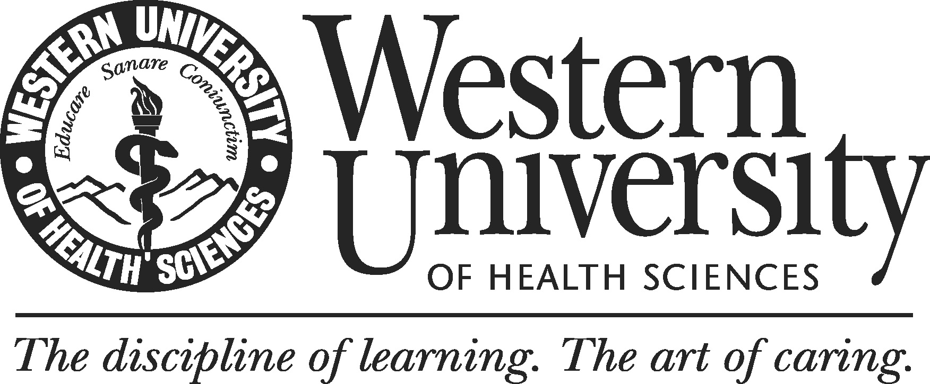

Western University of Health Sciences
Co-Curricular Program Review: Standards
November 13, 2013

Western University of Health Sciences recognizes the important role co-curricular programs play in the development of our students and on the institution as whole. The University is committed to reviewing its co-curricular programs to ensure currency and effectiveness. On the whole, the four standards below reflect WesternU’s commitment to providing a superior educational experience.

Standard 1. Mission and Vision

1.1 – The co-curricular program’s mission and vision are consistent with those of the University and they promote student learning.

Instructions:

Provide your department’s mission and/or vision statements:

Provide an assessment how well your mission and vision align with Standard 1.1. Are there any areas of strength? Weaknesses? Suggestions for improvement?

Standard 2. Products and Services

2.1 – The co-curricular program provides products and services that meet the needs of WesternU students and employees.

Instructions:

Provide a description of the program’s products and services:

Provide tables and/or charts displaying key program utilization statistics, making sure to disaggregate data by student and employee (if applicable):

Provide an assessment on how your products and services align with your mission and help you meet your goals and objectives. Are there any areas of strength? Weaknesses? Suggestions for improvement?

Standard 3. Program Fitness

  - – The program employs an adequate number of qualified staff to achieve its educational
objectives.

Instructions:

Provide Staff counts, Student-Staff Ratio, and Employee-Staff Ratio for previous five years:

Provide breakdown of staff by gender and ethnicity

Provide an assessment on how well your department meets Standard 3.1. Are there any areas of strength? Weaknesses? Suggestions for improvement?

3.2 – Availability and access to physical resources necessary to support the program (i.e, administrative offices, computers, instructional and information technologies, etc.) in carrying out its goals are in place.

Instructions:

Provide an overview of office, meeting, and other relevant physical space.

Provide an assessment on how well your program meets Standard 3.2? Are there any areas of strength? Weaknesses? Suggestions for improvement?

Standard 4. Program Effectiveness

4.1 – The program identifies outcomes related to student learning and program effectiveness and can demonstrate the degree to which these outcomes are achieved. The program critically evaluates findings and implements them into improvement efforts.

Instructions:

List your department’s program goals (i.e., broad statements that your program seeks to achieve):

List programs student learning outcomes:

Essay on Effectiveness

Guidelines: In this section, co-curricular programs should evaluate the degree to which they are achieving their stated goals and student learning outcomes. Programs should focus on 2 – 4 of their most important goals and student learning outcomes, making sure to evaluate at least one broad goal and one student learning outcome. The evaluation of program effectiveness is expected to be introspective and analytical, including review of literature, as appropriate, benchmarking, rigorous evidence, and thoughtful reflection. It may be helpful for programs to reflect back to Standard 1 – 3 of this guide as needed to add context to their findings.

Programs may identify goals for investigation based on any number of criteria. For example, programs may elect to investigate a goal that data has shown to be a weakness with the intention of understanding and improving results. Likewise, programs may explore goals in areas that show strength that could be further bolstered or become an opportunity for growth. In either case, programs should choose to study areas that speak directly to their fundamental mission, values, goals, and learning outcome statements.

Guiding questions (for each goal/outcome):

Using evidence and thoughtful reflection, how well is your program achieving the goal/outcome?

Are significant subgroups of you intended audience being effectively served (e.g., online versus classroom students, males versus females, part-time versus full-time, etc.)?
Are there areas of strength within your findings? Are there opportunities related to this area?

Do your findings show areas where goals/objectives are not being met? If so, what actions are necessary to improve results in this area?

Are there benchmarks from professional associations or comparable institutions that can inform you are how you are doing?

Summary

Indicate top three areas of strength:
1.

2.

3.

Indicate top three areas in need of improvement?
1.

2.

3.

Indicate action plans resulting from program review (add numbers as necessary):
1.

2.

3.

