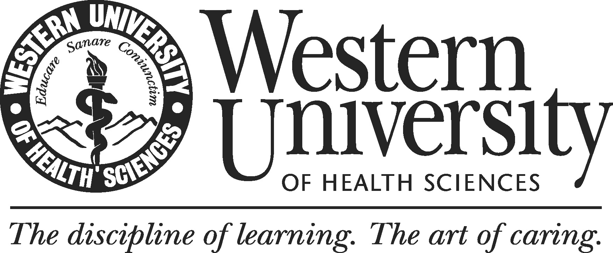

Team Decision Rubric (Academic Program)

Please rate the following program review criteria using the following:
1= NOT DONE (Not progress, does not exist)
2=NEEDS IMPROVEMENT (underdeveloped, problematic, inappropriate)
3=DONE (developed but lacking quality/depth)
4=DONE WELL (complete, comprehensive, appropriate, well-defined)
N/A =NOT APPLICABLE

Area/Component | Evaluation  (1, 2, 3, 4, or N/A)
- GENERAL OBSERVATIONS
1. The quality of the self-study is adequate.
2. The findings are supported by evidence.
3. The program use appropriate benchmarks to assess its findings.
4. The program use data (e.g. assessment results, institutional data etc.) for its improvement.
5. The analysis of the findings is adequate.
COMMENTS:

TOTAL SCORE ____________

- MISSION, HISTORY AND GOALS OF THE PROGRAM
1. Program mission is established.
2. Program mission is appropriate to the field
3. Program mission aligns to university mission. | .
4. Program mission promotes student learning.
5. Program mission guides program’s planning and decision making.
6. Program goals are clearly stated.
COMMENTS:

TOTAL SCORE ____________

- STUDENT LEARNING OUTCOMES
1. Student learning outcomes are clearly stated.
2. Student learning outcomes are aligned with the University’s eight institutional outcomes domains.
3. Student learning outcomes are evaluated with appropriate methods and the evidence is provided.
4. Student learning outcomes are regularly reviewed.
5. Assessment results are systematically shared within the program and used to guide curricular decisions.
6. The program uses the assessment results to improve students’ learning.
COMMENTS:

TOTAL SCORE ____________

- CURRICULUM
1. Curriculum content is well organized, appropriate and includes generally accepted experiences for the degree.
2. The curriculum aligns stated learning outcomes.
3. Curriculum content helps students achieve the stated outcomes at the program and institutional levels.
4. The program publishes student learning outcomes, at the course, program, and institutional level on all course syllabi.
5. The program provides adequate experiences and knowledge that will prepare them for success after graduation.
COMMENTS:

TOTAL SCORE ____________

- FACULTY
1. There are adequate numbers of faculty to fulfill mission.
2. Faculty responsibilities, workload, and training opportunities align with the University’s expectations for teaching, service, scholarship, and research.
3. Faculty’s qualifications are adequate to fulfill mission.
4. Professional development opportunities, faculty support services and resources are available to faculty.
COMMENTS:

TOTAL SCORE ____________

- STUDENT BODY
1. The program has a healthy application pool.
2. The program periodically reviews admissions data.
3. Outcome metrics are used to inform program improvement efforts.
4. Students are aware of program requirements and program learning outcomes.
COMMENTS:

TOTAL SCORE ____________

- PHYSICAL FACILITIES
1. The program has the physical resources (i.e., classroom space, research space, faculty and administrative offices) in carrying out its goals.
2. The program has the sufficient IT resources in carrying out its goals.
COMMENTS:

TOTAL SCORE ____________

- STAFF
1. There are adequate numbers of staff to fulfill mission.
2. Staffing qualifications are adequate to fulfill mission.
3. Adequate professional develop opportunities, staff support services and resources are available to staff.
COMMENTS:

TOTAL SCORE ____________

- EXTERNAL ENVIRONMENT OF THE PROGRAM
1. The program regularly reviews external developments outside that may impact their academic unit.
COMMENTS:

TOTAL SCORE ____________

- FINDINGS AND RECOMMENDATION
1. Identify the program’s most significant strengths.

2. Identify the program’s most significant weaknesses.

3. Comment on the adequacy of program’s self-identified plans for improvement.

4. Identify any additional recommendations you have for the program other than those suggested in the self-study.

