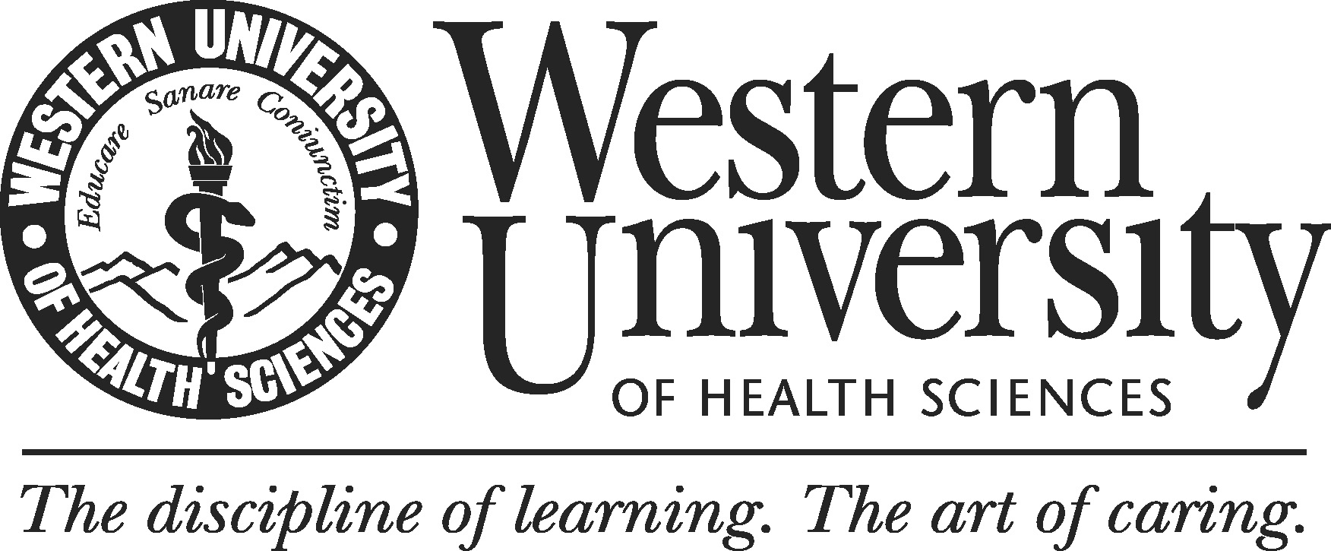

Team Interview Guide

During the site-visit, it is crucial for an external review team to understand institutional contexts by meeting with institutional personnel. This guide is intended to help your team prepare for the meetings and ask questions that will result in beneficial information for your external review report.

Overview
The interviews during the site-visit will be Structured Interviews and/or Semi-structured Interviews. Whether utilizing Structured Interviews or Semi-structured Interviews depends on what kinds of information the external review team try to obtain.

Structured Interviews
- Interview questions are pre-planned.
- External reviewers and participants engage in a formal interview.
- External reviewers ask each participant the same series of questions. The order and phrases of the questions are kept consistent.
- Interview questions are mostly closed-ended.
- The variations of responses are generally limited (yes/no, or some limited choices available).
- A self-administered questionnaire is a type of structured interview.
- The interview results are typically analyzed quantitatively.

Semi-structured Interviews
- Interview questions and topics are pre-planned.
- External reviewers and participants engage in a formal interview.
- Interview questions are mostly open-ended, which is highly encouraged for the meetings. Participants can choose their own terms when answering questions.
- Interviews allow participants the freedom to express their views in their own terms in their answers.
- The interview results are typically analyzed qualitatively.

Types of topics in questions
- Behaviors...…………………… what a person has done or is doing
- Opinions/values ………………. what a person thinks about the topic
- Feeling..………………………. how a person feel about the topic
- Knowledge.…………………… facts about a topic
- Sensory..………………………. what people have seen, touched, heard, tasted or smelled
- Background/demographics…… standard background questions, such as age, education etc.

**Note that the above questions can be asked in terms of past, present or future.

Facilitating the meeting

Prior to meetings
- Review the program’s self-study documents and any accompanying appendices.
- Develop questions and possible follow-up questions based on your inquiry (confirmation, clarification, curiosity, etc.)

At the interview
- Explain the purpose of the interview.
- Address terms of confidentiality.
- Explain the format of the interview.
- Indicate how long the interview takes.
- Tell them how to get in touch with you later if they want to.
- Ask them if they have any questions before you both get started with the interview.
- Reference self-reports or other documents that the program has submitted, if help.
- Don’t count on your memory to recall their answers.

Immediately after interview
- Verify if the recorder, if used, worked throughout the interview.
- Write down any notes and observations made during the interview.

Tips for the interview

- Ask one question at time.
- Word questions clearly.
- Remain as neutral as possible.
- Encourage responses.
- Don’t lose control of the interview.
- Before asking about controversial matters (such as feelings and conclusions), first ask about some facts.
- Ask questions about the present before questions about the past or future.
- Avoid wording that might influence answers (e.g., suggestive, judgmental wordings).
- Develop rapport with participants.
- Listen carefully and confirm you understanding by paraphrasing back to participants what you think you heard.
- Take notes so you can refer to them when writing the team report.
- Ask for concrete examples.
- Conclude by giving the participants the opportunity to share anything else that may be relevant.
- Sample discussion starters:
- Help us understand…
- Could you clarify…?
- We recognize that…
- We understand from the self-study that…
- What led to this conclusion?
- Is this characteristic of…?
- What factors contributed to these results?
- Please walk us through ….
- I would love to hear some other voices on this topic. Would someone else be willing to share their perspective or experience?
- Is there anything else you think would be helpful for our team to know about your program?
- We’ve been talking about (some topic) and now I’d like to move on to (another topic).

References
Harris, L. R., and Brown G.T.L. (2010). Mixing interview and questionnaire methods: Practical problems in
aligning data. Practical Assessment, Research & Evaluation, 15 (1). 1-19. Retrieved October 20, 2014,
http://pareonline.net/getvn.asp?v=15&n=1
McNamara, C. (2009). General Guidelines for Conducting Research Interviews Retrieved October 9, 2014,
from http://managementhelp.org/businessresearch/interviews.htm
Practical tools for international development. Retrieved October 9, 2014 from
http://www.tools4dev.org/resources/how-to-do-great-semi-structured-interviews/
Qualitative Research Guidelines Project. Retrieved October 9, 2014 from http://www.qualres.org/
WASC Accreditation Visiting Committee Training
WASC Senior College and University Commission. Conducting Interviews during institutional visits: Recommended Practices and Guidelines

