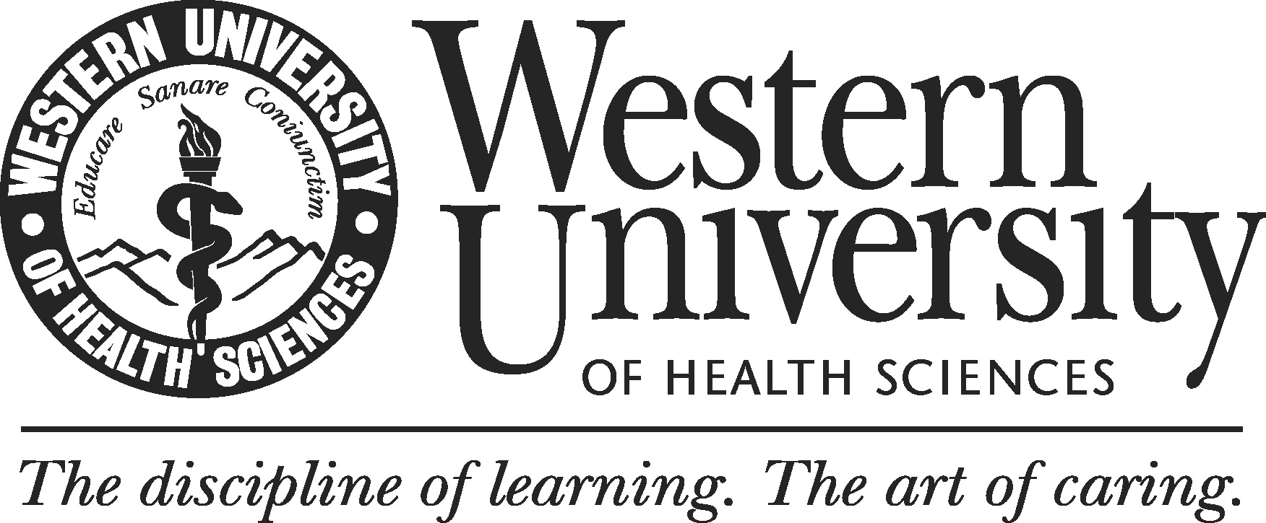

ANIMAL ADOPTION AGREEMENT
And
Waiver of Liability, Assumption of Risk, and Indemnity Agreement

I, ______________________________, have requested permission to adopt _________ (enter number of animals) ____________________________ (enter common name of animal(s), hereinafter “the Animal(s).” I acknowledge and agree that I am permitted to take possession and control of the Animal(s) on the express condition that the Animal(s) will be kept as a household pet or pets, and will not be used for any commercial purpose. Without limitation, the Animal(s) may not be sold, bred or used as a food source for any other animal species. I agree to humanely care for the Animal(s) for the duration of its or their natural life or lives.

In consideration of being permitted to adopt the Animal(s), I, for myself, my heirs, personal representatives and assigns, do hereby release, waive, discharge, and covenant not to sue Western University of Health Sciences, its officers, employees, and agents for any claim of damage or loss of any kind, whether for personal injury, property damage, accident, illness or death that may be caused to me or any other person, or to any property, by reasons of the adoption, ownership, care, possession, or contact with the Animal, whether or not such damage or loss results from any error, omission or negligence of Western University of Health Sciences, or any of its officers, employees, or agents.

Assumption of Risks: Ownership, possession and care of any lab animal carries with it certain inherent risks that cannot be eliminated regardless of the care taken to avoid injuries. I further understand that these animals may carry or be infected with organisms, bacteria and protozoa that are transmissible to humans and other animals. The specific risks vary from one animal to another, but the risks range from 1) minor injuries such as scratches, bruises, and sprains to 2) major injuries such as eye injury or loss of sight, joint or back injuries, heart attacks, and concussions to 3) catastrophic injuries including paralysis and death. I know, understand, and appreciate these and other risks that are inherent to lab animal ownership, possession and care. I hereby acknowledge that this animal adoption is voluntary and that I knowingly assume all such risks.

Indemnification and Hold Harmless: I agree to indemnify and hold Western University of Health Sciences, and its officers, employees and agents, harmless from any and all claims, actions, suits, procedures, costs, expenses, damages and liabilities, including, but not by way of limitation, attorneys’ fees incurred in the defense of any claim or action, that arises out of, or is directly or indirectly related to my adoption, ownership, possession or control of the Animal.

Severability: The undersigned further expressly agrees that the foregoing waiver and assumption of risks agreement is intended to be as broad and inclusive as is permitted by the law of the State of California and that if any portion thereof is held invalid, it is agreed that the balance shall, notwithstanding, continue in full legal force and effect.

I represent and acknowledge that I have read this ANIMAL ADOPTION AGREEMENT and Waiver of Liability, Assumption of Risk, and Indemnity Agreement, and fully understand its terms. I understand that I am giving up substantial rights, including my right to sue. I acknowledge that I am signing the agreement freely and voluntarily, and intend by my signature to be a complete and unconditional release of all liability to the greatest extent allowed by law.

Date: _____________________ ___________________________________
[Signature]

